ShadowTrace: AI Based Intrusion Detection Game

A PROJECT REPORT

Submitted by

NANDHINI VELMURUGAN (2116241901063)

in partial fulfillment for the award of the degree of

BACHELOR OF ENGINEERING

in

COMPUTER SCIENCE AND ENGINEERING (CYBER SECURITY)


RAJALAKSHMI ENGINEERING COLLEGE

An Autonomous Institute

CHENNAI

NOVEMBER 2026

RAJALAKSHMI ENGINEERING COLLEGE CHENNAI

BONAFIDE CERTIFICATE

Certified that this project report “SHADOWTRACE: AI BASED INTRUSION DETECTION GAME” is the bonafide work of “NANDHINI VELMURUGAN” who carried out the project work under my supervision.

SIGNATURE
Dr. Bhuvana S, Ph.D.,

ASSISTANT PROFESSOR(SG)
Department of Computer Science and Engineering (Cyber Security) Rajalakshmi Engineering College Chennai - 602 105

Submitted to Project Viva-Voce Examination held on

SIGNATURE OF THE INTERNAL EXAMINER
ABSTRACT

Artificial Intelligence enables game characters to perceive their surroundings, make decisions, and respond dynamically to changing situations. ShadowTrace: AI-Based Intrusion Detection Game presents an interactive, grid-based stealth game developed using Python and Pygame to demonstrate the integration of multiple AI techniques for intelligent non-player character (NPC) behaviour.
In the game, the player acts as an intruder who must collect three evidence items and reach the exit without being caught by an AI-controlled security guard. The guard uses a Finite State Machine (FSM) with four states; Patrol, Investigate, Chase, and Return to adapt its behaviour based on environmental events. Line-of-sight detection and noise monitoring enable threat perception, while the A algorithm* with a Manhattan-distance heuristic supports obstacle-aware navigation. Additionally, Minimax search with Alpha-Beta pruning assists in evaluating decisions, such as investigating suspicious noises or continuing a patrol.
The system follows a modular architecture integrating perception, decision-making, behavioural control, and pathfinding. The prototype demonstrates dynamic guard behaviour, evidence collection, and escape or caught outcomes. Its performance is intended to be evaluated through repeatable gameplay scenarios, examining state transitions, path validity, detection response, and decision-making efficiency, with comparison against a fixed-route baseline. Overall, ShadowTrace demonstrates the practical application of classical AI algorithms in creating responsive and strategically engaging game behaviour.

Keywords: Artificial Intelligence, Game AI, Intrusion Detection, Finite State Machine, A* Pathfinding, Minimax, Alp`ha-Beta Pruning.

ACKNOWLEDGEMENT
First and foremost, we thank Almighty God for enabling us to complete this project successfully. We express our sincere gratitude to our Chairman, Mr. S. Meganathan, B.E., F.I.E., for his dedicated efforts in providing quality education at this esteemed institution. We are deeply grateful to our beloved Chairperson, Dr. Thangam Meganathan, Ph.D., for her constant motivation and encouragement, which inspired us throughout the completion of this project. We also thank our Vice Chairman, Mr. Abhay Shankar Meganathan, B.E., M.S., for providing the necessary infrastructure and facilities.
We express our sincere gratitude to our College Principal, Dr. S. N. Murugesan, M.E., Ph.D., and Dr. P. Tamilselvi, Ph.D., Professor and Head, Department of Computer Science and Engineering (Cyber Security), for their support and encouragement.
We are especially thankful to our project guide, Dr. Bhuvana S., Ph.D., Assistant Professor (SG), for her valuable guidance, continuous encouragement, and support throughout the project. Finally, we thank our parents and friends for their direct and indirect contributions, encouragement, and support in the successful completion of this project.

NANDHINI VELMURUGAN (2116241901063)

iv
TABLE OF CONTENTS
v
CHAPTER NO. | TITLE | PAGE NO.
 | ABSTRACT | iii
 | LIST OF TABLES | vii
 | LIST OF FIGURES | viii
1 | INTRODUCTION | 1
 | 1.1 BACKGROUND | 1
 | 1.2 PROBLEM STATEMENT | 2
 | 1.3 OBJECTIVES | 2
 | 1.4 SCOPE | 3
 | 1.5 SECURITY REQUIREMENTS / SECURITY CONSIDERATIONS | 3
 | 1.6 SDG ALIGNMENT | 4
2 | LITERATURE REVIEW | 5
 | 2.1 EXISTING SYSTEM WITH SECURITY APPROACHES | 5
 | 2.2 RESEARCH GAPS | 8
 | 2.3 PROPOSED SYSTEM | 9
 | 2.3.1 OVERVIEW OF THE PROPOSED SYSTEM | 9
 | 2.3.2 OBJECTIVES OF THE PROPOSED SYSTEM | 9
 | 2.3.3 ADVANTAGES OF PROPOSED SYSTEM | 10
3 | SYSTEM DESIGN | 11
 | 3.1 SYSTEM ARCHITECTURE | 11
 | 3.2 MODULE DESIGN | 12
 | 3.3 DATA FLOW / UML DIAGRAMS | 12
 | 3.4 THREAT MODEL AND ATTACK SURFACE | 13
 | 3.5 SECURITY CONTROLS | 13
4 | SYSTEM DESCRIPTION | 16
 | 4.1 DATA COLLECTION | 18
 | 4.2 DATA PREPROCESSING | 18
 | 4.2.1 ALGORITHMS / METHODOLOGY | 18
 | 4.2.2 RESULTS AND DISCUSSION | 20
5 | CONCLUSION | 24
 | REFERENCES  FUTURE SCOPE | 25  26
 | APPENDIX  vi  Iv | 28
LIST OF TABLES
viiii
TABLE NO. | TITLE | PAGE NO.
1.1 | SDG ALIGNMENT | 4
2.1 | LITERATURE SURVEY | 5
3.1 | TOOLS AND TECHNOLOGIES | 12
3.2 | LIST OF MODULES | 12
3.3 | GUARD FSM STATES | 13
3.4 | THREAT MODEL | 16
3.5 | SECURITY CONTROLS | 17
4.1 | PLANNED TEST CASES | 22
A.1 | WEEKLY DEVELOPMENT LOG SUMMARY | 28
LIST OF FIGURES
viii
FIGURE | TITLE | PAGE NO.
3.1 | SYSTEM ARCHITECTURE | 11
3.2 | DATA FLOW DIAGRAM (LEVEL 1) | 14
3.3 | GUARD FSM STATE TRANSITION DIAGRAM | 15
3.4 | DEVELOPMENT AND TESTING WORKFLOW | 15
4.1 | PROTOTYPE: GUARD IN PATROL STATE (INTEL 0/3) | 20
4.2 | PROTOTYPE: GUARD IN CHASE STATE (INTEL 1/3) | 21
4.3 | PROTOTYPE: MISSION ACCOMPLISHED (ESCAPE OUTCOME) | 21
4.4 | PROTOTYPE: MISSION COMPROMISED (CAUGHT OUTCOME) | 22

CHAPTER 1
INTRODUCTION

1.1 BACKGROUND
Artificial Intelligence (AI) is a central part of modern interactive games, where non-player characters (NPCs) must perceive their surroundings, make decisions and move through the game world in ways that feel believable to the player. In stealth games, the quality of the opposing NPC largely determines the quality of the experience. A guard who follows a fixed, predictable route can be memorised and exploited, whereas a guard who reacts to what it can see and hear keeps the player alert and makes the game challenging in a fair way.
ShadowTrace is a compact top-down stealth game developed as an academic AI project. The player takes the role of an intruder inside a grid-based facility and must collect three evidence items and reach the exit without being caught by a security guard. The scenario is deliberately framed as an intrusion detection problem: the guard acts as a detection-and-response system that monitors its environment through limited sensors (line of sight and noise), decides whether an observed event is suspicious, and responds by investigating or pursuing the intruder. The game therefore offers a small, understandable setting in which detection, decision-making and response can be designed, observed and tested.
The project brings together four well-established game-AI techniques, each of which solves a different part of the guard's problem:
- Finite State Machine (FSM): organises the guard's behaviour into four states (Patrol, Investigate, Chase and Return) with defined transitions between them.
- Perception (line of sight and noise): limits what the guard knows. Noise events, such as those produced when evidence is collected, and visual detection trigger changes in behaviour, so the guard never has perfect information about the player.
- A* pathfinding computes an obstacle-aware route across the grid once the guard has chosen a destination.
- Minimax with Alpha-Beta pruning: a shallow adversarial search that helps the guard choose between candidate actions, such as investigating a noise or continuing its patrol, while pruning branches that cannot influence the final choice.
These components are kept deliberately separate. Minimax decides what the guard should do, the FSM manages which behaviour is currently active, and A* determines how the guard gets to its target. This separation keeps the design modular and makes each component easy to test on its own.

1.2 PROBLEM STATEMENT
The problem addressed in this project is to develop a top-down stealth game in which the player must collect three evidence items and escape without being caught by a security guard. In many simple stealth games, the guard follows a fixed, predictable route, which makes the game easy to exploit and removes the need for the player to think strategically. The challenge is to replace this predictable behaviour with a guard that reacts to player noise, detects the player through line of sight and navigates around obstacles, while keeping the design simple enough to be understood, implemented and tested within a semester project.
The motivation is to demonstrate practical applications of Artificial Intelligence through an interactive game. The project is significant because it combines game development, intelligent decision-making, path-finding and adversarial search in a small environment where the effect of each technique can be clearly observed.

1.3 OBJECTIVES
The objectives of the project are as follows:
- Develop a compact, grid-based stealth game environment.
- Allow the player to collect three evidence items and reach the exit.
- Implement a Finite State Machine (FSM) for the guard with four states: Patrol, Investigate, Chase and Return.
- Use noise events and line-of-sight checks to detect player activity.
- Apply A* pathfinding to navigate around obstacles.
- Incorporate Minimax with Alpha-Beta pruning into the decision-planning component.
- Evaluate the guard's behaviour using repeatable gameplay test scenarios.
Expected outcome: an interactive prototype demonstrating AI-driven guard behaviour and a clear player objective.

1.4 SCOPE
The scope of the project is intentionally limited so that the AI components can be implemented and evaluated properly. The work covers the following:
- A single compact grid-based map with one security guard, three evidence items and one exit.
- The gameplay sequence Explore, Collect Evidence, Avoid Guard and Escape.
- Guard behaviour built from a four-state FSM, noise-based and line-of-sight perception, A* navigation and a shallow Minimax decision with Alpha-Beta pruning.
- A desktop prototype implemented in Python using Pygame.
- Evaluation using repeatable, manually designed gameplay test scenarios and a comparison with a fixed-route baseline guard.
Multiple guards or levels, online or multiplayer play, machine-learning-based agents and the analysis of real network traffic are outside the scope of this phase. ShadowTrace uses intrusion detection as a gameplay metaphor and is not a network security tool.

1.5 SECURITY REQUIREMENTS / SECURITY CONSIDERATIONS
ShadowTrace models an intrusion-and-detection scenario inside a local game. Its security considerations therefore concern the integrity, fairness and availability of the game and its AI, rather than the protection of external user data. The following requirements have been identified for the prototype:
- Integrity of game state: player movement, collisions and evidence collection must follow the game rules. The player must not be able to pass through walls or collect the same evidence item twice.
- Input validation: key presses and interaction commands must be validated against the map boundaries and obstacles before the world state is updated.
- Limited information for the guard: the guard must detect the player only through line of sight and noise events and must not read the player's position directly. This keeps detection fair and realistic.
- Availability and responsiveness: the guard's decision logic, including the Minimax search, must have a bounded depth so that it responds within the real-time game loop.
- Robust pathfinding and state handling: invalid or unreachable paths and unexpected FSM transitions must be detected and recovered from rather than leaving the guard frozen or causing a crash.
- Repeatability and traceability: test scenarios and their outcomes must be reproducible and recorded so that the guard's behaviour can be verified.
- Trusted components: Python and Pygame should be obtained from their official distribution sources.

1.6 SDG ALIGNMENT
The project is aligned with the following United Nations Sustainable Development Goals (SDGs). The alignment is summarised in Table 1.1.
Table 1.1 SDG Alignment
S. No. | SDG No. & Goal | Relevant SDG Target | Project Contribution / Alignment
1 | SDG 4: Quality Education | Target 4.4: Increase the number of youth and adults who have relevant skills, including technical skills (abridged). | The project gives a hands-on, interactive way to learn and demonstrate AI concepts such as pathfinding, state machines and adversarial search, and can be used as a teaching demonstration of game AI.
2 | SDG 9: Industry, Innovation and Infrastructure | Target 9.5: Enhance scientific research and upgrade technological capabilities and encourage innovation (abridged). | The project develops a modular AI prototype and builds software-engineering and AI capability that is relevant to the digital entertainment and simulation industries.

CHAPTER 2
LITERATURE REVIEW

2.1 EXISTING SYSTEM WITH SECURITY APPROACHES
In simple stealth games, the opposing security guard often follows a predefined patrol route and reacts only when the player enters a specified detection area. Although this approach is easy to implement, it can make the gameplay predictable. Once the player learns the guard's movement pattern, the challenge can be reduced to memorizing the route rather than making strategic decisions. A more effective game AI system should be capable of perceiving environmental events, responding to suspicious activities, navigating around obstacles, and selecting appropriate actions according to the current game state.

Several established Artificial Intelligence techniques can address these limitations. Heuristic search algorithms support efficient navigation, finite-state-based behavior management provides structured control over non-player characters (NPCs), and adversarial search enables the evaluation of alternative actions. Autonomous-character research also explores movement, pursuit, evasion, and obstacle avoidance. The following literature survey examines relevant works and their applicability to the proposed ShadowTrace system.
Table 2.1 Literature survey
S. NO. | Author(s) and Year | Paper/Book Title | Methodology/Algorithm | Limitations
1 | Hart, Nilsson and Raphael (1968) [1] | A Formal Basis for the Heuristic Determination of Minimum Cost Paths | A* heuristic search and minimum-cost path determination. | Efficiency depends on the heuristic and the size of the search space.
2 | Millington and Funge (2016) [2] | Artificial Intelligence for Games | Game AI techniques, including pathfinding, decision-making, and autonomous behavior. | General techniques require adaptation to the specific game environment.
3 | Orkin (2006) [3] | Three States and a Plan: The AI of F.E.A.R. | Goal-oriented planning and layered game AI architecture. | The techniques address a more complex action game and may require simplification for a small prototype.
4 | Russell and Norvig (2021) [4] | Artificial Intelligence: A Modern Approach | Search algorithms, intelligent agents, adversarial search, and decision-making. | Computational cost can increase with search depth and branching factor.
5 | Rabin, Ed. (2002) [5] | AI Game Programming Wisdom | Practical game AI techniques and implementation approaches. | Techniques may require tuning and modification for the target game.
6 | Reynolds (1999) [6] | Steering Behaviors for Autonomous Characters | Autonomous movement, path following, pursuit, evasion, and obstacle avoidance. | Steering behavior alone do not provide a complete high-level decision-making system.
7 | Knuth and Moore (1975) [9] | An Analysis of Alpha-Beta Pruning | Analysis of Alpha-Beta pruning for reducing the number of game-tree nodes explored during adversarial search. | Search efficiency depends on factors such as move ordering and tree structure.
8 | LaValle (2006) [12] | Planning Algorithms | Planning and search techniques for navigating state spaces and finding paths. | General planning methods can be more complex than required for a small grid-based game.
9 | Buckland (2004) [13] | Programming Game AI by Example | Practical game AI implementation, including finite-state machines and autonomous agents. | Example implementations require adaptation to the game's particular rules and architecture.
10 | Nystrom (2014) [14] | Game Programming Patterns | State pattern and structured approaches to managing changing software behavior. | The state pattern is a software design technique and does not independently provide perception or intelligent decision-making.

Hart, Nilsson and Raphael (1968) [1] introduced a formal basis for heuristic search to determine minimum-cost paths. Their work provides the theoretical foundation for the A* algorithm, which evaluates nodes using the sum of the cost already incurred and an estimate of the remaining cost. In ShadowTrace, A* is applied to the grid-based environment using the Manhattan-distance heuristic, enabling the security guard to navigate around walls and reach a selected destination.

Millington and Funge (2016) [2] discuss a range of Artificial Intelligence techniques used in game development, including path finding, autonomous behavior, and decision-making. These techniques provide a foundation for designing intelligent NPCs that respond to events rather than relying entirely on predetermined movement. Similarly, Orkin (2006) [3] describes the layered AI architecture used in F.E.A.R., demonstrating the importance of coordinating planning and character behavior. ShadowTrace follows a simplified modular approach in which decision-making, state management, and navigation are handled by separate components.

Russell and Norvig (2021) [4] explain fundamental AI concepts, including intelligent agents, heuristic search, and adversarial decision-making. These concepts are relevant to ShadowTrace because the guard must evaluate its environment and choose appropriate actions while operating with limited information. Rabin (2002) [5] presents practical game AI techniques and implementation approaches that are useful for translating theoretical algorithms into working game systems.

Reynolds (1999) [6] examined steering behaviors for autonomous characters, including pursuit, evasion, path following, and obstacle avoidance. This work highlights the importance of movement behaviors in creating responsive game characters. In ShadowTrace, the guard's movement is primarily determined by A* pathfinding, while its current behavioral state determines whether it patrols, investigates a noise, chases the player, or returns to its patrol route.

Knuth and Moore (1975) [9] analyzed the Alpha-Beta pruning technique used in adversarial game-tree search. Their work examines the correctness and computational behavior of pruning, which avoids exploring branches that cannot affect the final decision. ShadowTrace incorporates a shallow Minimax search with Alpha-Beta pruning to evaluate candidate guard actions while keeping the computational workload suitable for a real-time game loop.

LaValle (2006) [12] provides a comprehensive treatment of planning algorithms and search-based approaches to navigation. The work offers broader theoretical context for representing environments as states and finding routes through them. Buckland (2004) [13] focuses on practical game AI programming, including the implementation of autonomous agents and finite-state machines. These approaches are relevant to ShadowTrace's use of a four-state Finite State Machine consisting of Patrol, Investigate, Chase, and Return.

Nystrom (2014) [14] explains the State pattern as a software design approach for organizing behavior that changes according to an object's current state. This approach supports modular implementation and makes transitions between behaviors easier to manage. In ShadowTrace, the guard's state determines its active behavior, while perception events such as visual detection and suspicious noise trigger transitions between states.

Overall, the reviewed literature establishes the usefulness of heuristic search, structured behavioral control, autonomous-character techniques, and adversarial decision-making in game AI. However, the selected publications address different aspects of the problem, and they do not by themselves establish the effectiveness of the combination implemented in ShadowTrace. The proposed project brings these techniques together in a compact stealth-game environment, allowing their integration and behavior to be examined through repeatable gameplay scenarios.

2.2 RESEARCH GAPS
1. Literature findings. The game-AI literature describes pathfinding, state machines and decision-search algorithms as useful components for developing responsive game agents.
2. Limitations. A small stealth game must balance believable guard behaviour with simple, understandable and testable rules. More advanced approaches in the literature are designed for larger and more complex games.
3. Refined research gap. The gap addressed here is the integration of noise-based investigation, visual detection, state-based guard behaviour and obstacle-aware navigation into one compact stealth-game scenario.
4. Project response. ShadowTrace proposes a modular design combining an FSM, noise and line-of-sight sensing, A* pathfinding and a Minimax / Alpha-Beta decision component. Implementation and evaluation will determine how effectively these components work together.

2.3 PROPOSED SYSTEM

2.3.1 OVERVIEW OF THE PROPOSED SYSTEM
The proposed system is a top-down stealth game on a single grid map containing walls, three evidence items, an exit and one security guard. The gameplay sequence is Explore, Collect Evidence, Avoid Guard and Escape. The player moves through the map with the keyboard and collects the evidence items. Collecting an item produces a noise event, so the player must balance the need to reach the evidence against the risk of alerting the guard.
The guard is controlled by an AI controller built around a four-state FSM. In the Patrol State it follows a predefined route. When it hears a noise, it enters the Investigate State and moves towards the last known noise location. If the player enters its line of sight, it enters the Chase state and pursues the player. When the player is no longer detected it enters the Return state and resumes its patrol. A* pathfinding provides the routes for all this movement, and a Minimax search with Alpha-Beta pruning supports the choice between candidate guard actions. The overall structure is shown in Figure 3.1.

2.3.2 OBJECTIVES OF THE PROPOSED SYSTEM
- Provide a guard that reacts to player noise rather than following a fixed route only.
- Detect the player through a limited line-of-sight check so that the guard does not have perfect information.
- Navigate around walls and obstacles using A* pathfinding.
- Select guard actions using a shallow Minimax search with Alpha-Beta pruning.
- Keep the system modular so that each component can be developed and tested independently.
- Evaluate the AI-controlled guard against a fixed-route guard that does not use sensing or A* pathfinding.

2.3.3 ADVANTAGES OF PROPOSED SYSTEM
- Less predictable behaviour: the guard reacts to events instead of repeating a fixed route.
- Realistic and fair detection: limited vision and noise-based perception mean the guard works with incomplete information.
- Obstacle-aware movement: A* routes the guard around walls and recalculates when a path becomes invalid.
- Clear separation of responsibilities: decision-making, behaviour management and pathfinding are separate, which simplifies testing and debugging.
- Measurable behaviour: the guard can be evaluated using repeatable scenarios and recorded metrics.
- Low cost and easy to extend: the system run on an ordinary desktop using Python and Pygame, and further guards or maps can be added later.

CHAPTER 3
SYSTEM DESIGN

3.1 SYSTEM ARCHITECTURE
The architecture of ShadowTrace is shown in Figure 3.1. It consists of six connected blocks.
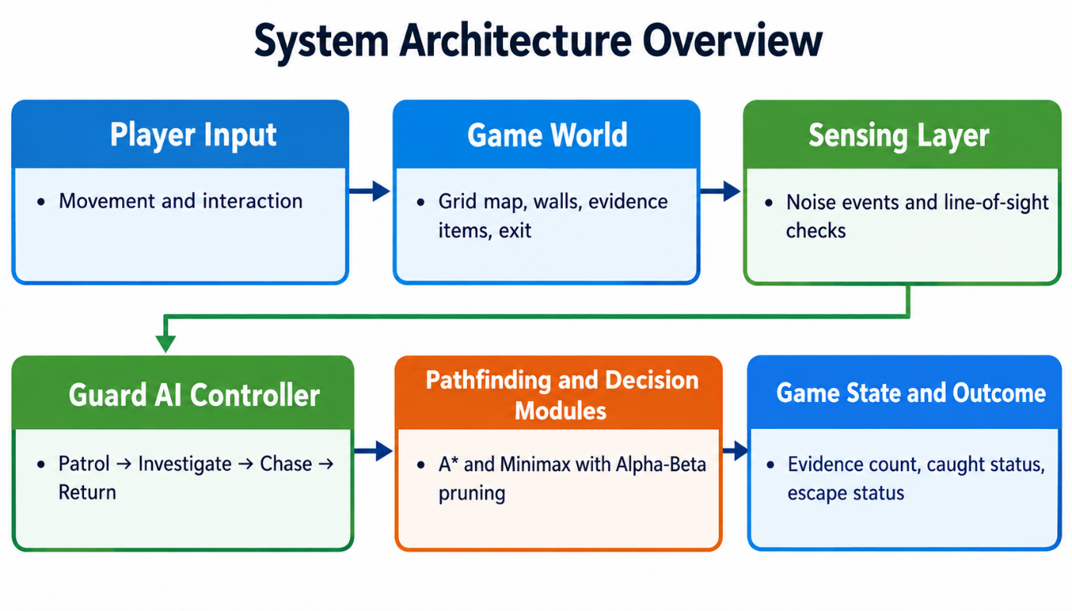
Figure 3.1 System Architecture
- Player Input: captures the player's movement and interaction commands.
- Game World holds the grid map, walls, evidence items and the exit.
- Sensing Layer: produces noise events and performs line-of-sight checks.
- Guard AI Controller: runs the FSM that moves the guard through Patrol, Investigate, Chase and Return.
- Pathfinding and Decision Modules: A* computes routes, and Minimax with Alpha-Beta pruning supports decision planning.
- Game State and Outcome records the evidence count, the caught status and the escape status.
The technologies used to build this architecture are listed in Table 3.1. Python and Pygame are suitable for a small 2D game prototype, and the selected algorithms demonstrate state-based behaviour, obstacle-aware navigation and adversarial decision-making.
Table 3.1 Tools and technologies
Item | Details
Programming language | Python
Framework / library | Pygame for 2D graphics, keyboard input, the game loop and collision handling
Algorithms | Finite State Machine (FSM), A* pathfinding, Minimax search, Alpha-Beta pruning
Software / hardware | Desktop development environment
Dataset | Custom grid map and manually designed gameplay test scenarios

3.2 MODULE DESIGN
The system is divided into the eight modules listed in Table 3.2.
Table 3.2 List of modules
S. No. | Module | Purpose
1 | Grid Map and Collision System | Represents the environment and checks movement against walls and map boundaries.
2 | Player Movement and Interaction | Moves the player and handles interaction with evidence items.
3 | Evidence Collection and Escape Condition | Tracks collected evidence and allowed escape once the objective is met.
4 | Noise and Line-of-Sight Detection | Generates noise events and checks whether the guard can see the player.
5 | Guard FSM | Manages the Patrol, Investigate, Chase and Return behaviours.
6 | A* Pathfinding | Calculates obstacle-aware routes for the guard.
7 | Minimax with Alpha-Beta Pruning | Selects between candidate guard actions using a shallow adversarial search.
8 | Testing and Result Logging | Runs the test scenarios and records the outcomes and metrics.

3.2.1 MODULE 1: WORLD AND PLAYER
Purpose: maintain the game map and allow the player to navigate the environment.
Inputs: directional key presses and interaction commands.
Output: the updated player position and game-world state.
The implementation approach is as follows:
- Represent the environment as a grid containing walkable cells and obstacles.
- Validate player movement against walls and map boundaries.
- Update the status of the evidence when the player collects an item.
- Track the number of items collected.
- Allow escape when the required objective is satisfied.

3.2.2 MODULE 2: GUARD AI
Input: the player position, noise events, the line-of-sight result and the map obstacles. The guard's behaviour is controlled by the FSM described in Table 3.3.
Table 3.3 Guard FSM states
State | Behaviour | Typical transition
Patrol | Follows a predefined route. | Investigate a noise event; Chase on visual detection.
Investigate | Moves towards the last known noise location. | Chase on visual detection; Return if nothing is found.
Chase | Pursues the player when visual detection succeeds. | Return when the player is no longer detected; the player is caught if the guard reaches them.
Return | Resumes the patrol after the player is no longer detected. | Patrol once the patrol route is rejoined.

A* pathfinding calculates the route around obstacles for each of these movements. A Minimax search with Alpha-Beta pruning is used as the decision component. Its game states, available actions and utility values are defined during implementation, as described in Section 4.2.1.

3.3 DATA FLOW / UML DIAGRAMS
The level 1 data flow diagram of the system is shown in Figure 3.2. The player is the only external entity. Four processes transform the player's input into the updated game state:
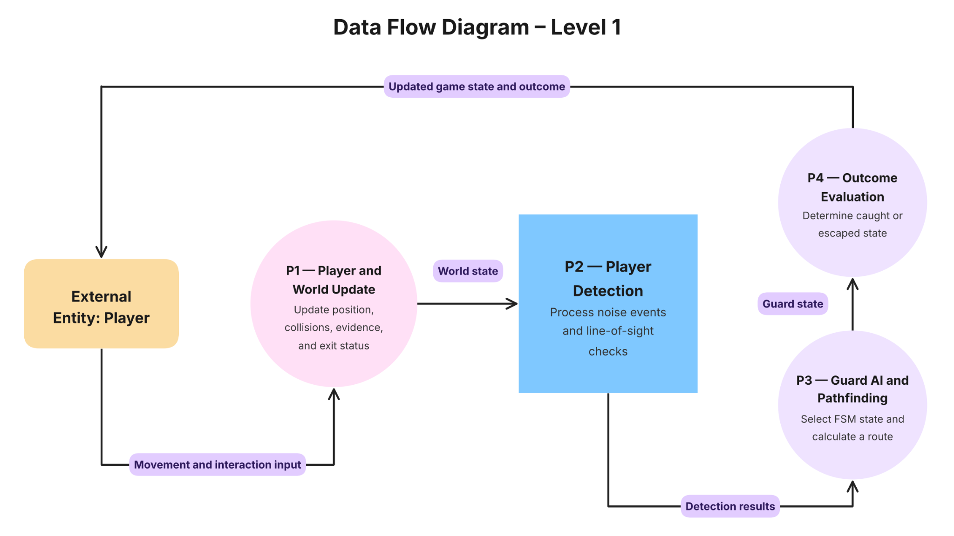
Figure 3.2 Data flow diagram (Level 1)
- P1: Player and World Update updates the position, collisions, evidence and exit status from the movement and interaction input.
- P2: Player Detection processes noise events and line-of-sight checks using the world state.
- P3: Guard AI and Pathfinding selects the FSM state and calculates a route from the detection results.
- P4: Outcome Evaluation determines the caught or escaped state from the guard state, and the updated game state and outcome are returned to the player.
The state-transition behaviour of the guard is shown in Figure 3.3.
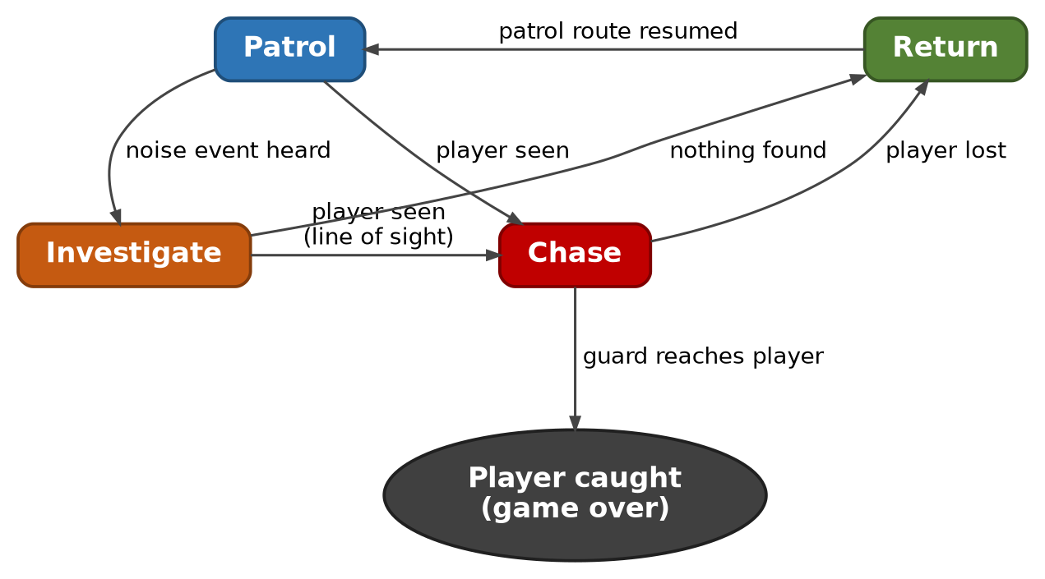
Figure 3.3 Guard FSM state transition diagram
The development and testing workflow is shown in Figure 3.4. It has seven steps: define the environment, implement the player mechanics, add the detection systems, build the guard FSM, add the guard intelligence (A* and Minimax / Alpha-Beta), test the behaviour, and evaluate the results.
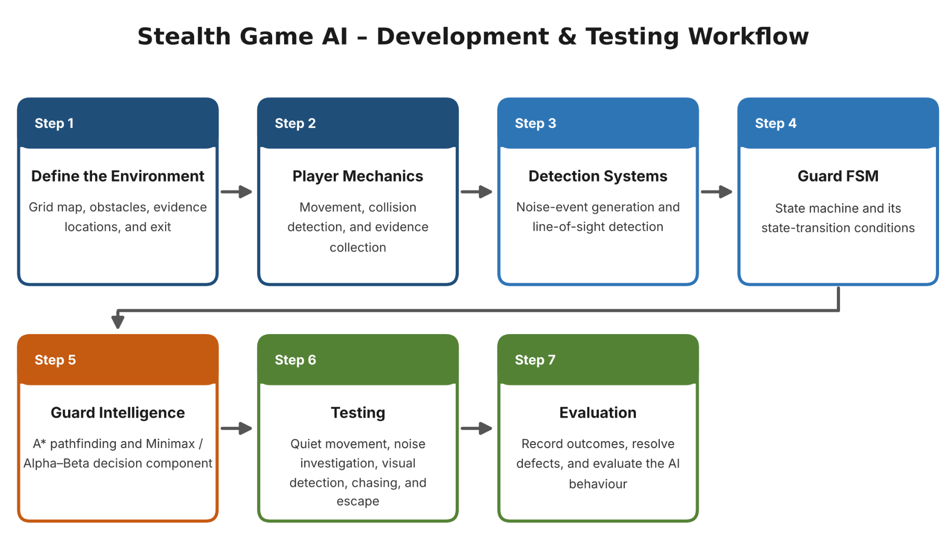
Figure 3.4 Development and testing workflow

3.4 THREAT MODEL AND ATTACK SURFACE
ShadowTrace is a local, single-player prototype, so its threat model is limited to threats against the integrity, fairness and availability of the game and its AI. The assets to be protected are the game state, the guard AI logic, the map data and the test logs. The relevant adversary is a player or tester who tries to cheat, break the guard's behaviour or exploit an unexpected situation. The identified threats are listed in Table 3.4.
Table 3.4 Threat model
ID | Threat | Affected component | Impact
T1 | Invalid input or out-of-range movement that bypasses collision rules | Player movement, grid map | Player passes through walls; game state becomes inconsistent
T2 | Repeated collection of the same evidence item or inconsistent evidence counts | Evidence collection | Objective can be completed unfairly
T3 | Guard receives information it should not have (for example the exact player position) | Sensing layer, guard AI | Detection becomes unrealistic and unfair
T4 | Unreachable target or invalid path produced during navigation | A* pathfinding | Guard freezes or behaves unpredictably
T5 | Unexpected or repeated state transitions, for example after repeated noise events | Guard FSM | Guard stops responding correctly
T6 | Search depth or branching that is too large for the real-time loop | Minimax / Alpha-Beta | Delayed guard response
T7 | Modification of map data or test logs | Map data, result logging | Unreliable test results

The attack surface of the prototype consists of the following entry points:
- the keyboard input (movement and interaction commands);
- the map data and any scenario configuration read by the game;
- the noise-event interface between the player’s actions and the guard's perception;
- the result logs written during testing;
- the third-party library (Pygame) on which the game depends.

3.5 SECURITY CONTROLS
The controls planned to address the threats above are listed in Table 3.5.
Table 3.5 Security controls

S. No. | Control | Description | Threat addressed
1 | Input and boundary validation | Every movement is checked against walls and map boundaries before the world state is updated. | T1
2 | Game-state tracking | Evidence status and count are tracked in game-state variables so each item can be collected only once. | T2
3 | Perception-only detection | The guard receives only line-of-sight and noise-event results, never the player's coordinates. | T3
4 | Path validation and recalculation | Paths are validated and recalculated when a target becomes unreachable or a path becomes invalid. | T4
5 | Controlled state transitions | Decision logic is separated from movement logic and state, and path are re-evaluated after important events. | T5
6 | Bounded search depth | A shallow Minimax depth with Alpha-Beta pruning keeps decision time low. | T6
7 | Trusted sources and repeatable tests | Python and Pygame are obtained from official sources, and test scenarios and logs are kept for repeatable verification. | T7

CHAPTER 4
SYSTEM DESCRIPTION

4.1 DATA COLLECTION
ShadowTrace does not use an external dataset. The data used by the system consists of a custom grid map that is designed manually and a set of manually designed gameplay test scenarios (Table 4.1). The game also generates runtime data while it is played: the player and guard positions, noise events, the active FSM state, the number of search nodes explored, and the outcome (caught or escaped). This runtime data is the basis for the evaluation metrics described in Section 4.2.2.

4.2 DATA PREPROCESSING
No statistical preprocessing is needed because the system does not learn from data. The preprocessing work in this project is the preparation of the environment and state representation used by the AI components:
- Grid encoding: the map is stored as a grid in which each cell is a walkable cell, a wall, an evidence location, the exit or the guard's start position.
- Coordinate handling: player and guard positions are expressed as grid-cell coordinates, which are used for movement, collision checks and distance estimates.
- Graph view for pathfinding: walkable cells are treated as nodes and neighbouring walkable cells as connections with a movement cost, which is the structure on which A* operates.
- Patrol route definition: a predefined route of walkable cells is specified for the Patrol state.

4.2.1 ALGORITHMS / METHODOLOGY
A* pathfinding.
A* searches for the grid for a minimum-cost route to a target cell. Each cell n is scored with f(n) = g(n) + h(n), where g(n) is the movement cost from the start to n and h(n) is a heuristic estimate of the remaining cost to the goal. On a four-directional grid the Manhattan distance, h(n) = |x1 - x2| + |y1 - y2|, is used as the heuristic. Before and during movement the path is validated, and it is recalculated when the target becomes unreachable or the path becomes invalid.
Finite State Machine.
The guard's behavior is organized in the four states Patrol, Investigate, Chase and Return (Table 3.3 and Figure 3.3). Transitions are triggered by perception events. Decision logic is kept separate from movement logic to avoid unnecessary state changes while the guard is moving.
Perception: line of sight and noise.
Visual detection uses a limited vision range and checks whether walls block the line between the guard and the player. Noise events are generated when the player performs suspicious actions such as collecting evidence. The guard is configured to investigate the location of a detected noise rather than automatically knowing where the player is. Separate checks are used for visual detection and for noise events, and both feed into the FSM.
Minimax with Alpha-Beta pruning.
Minimax is an adversarial search in which one player (MAX, the guard) chooses actions that maximise a game-state evaluation while the opponent (MIN, the player) is assumed to respond in the way that minimises it. In ShadowTrace the guard's candidate actions include Investigate Noise and Continue Patrol. A shallow search depth and a simple evaluation function that assigns scores to the outcomes of the guard's actions keep the search small enough for real-time play. Alpha-Beta pruning maintains two bounds, alpha (the best value MAX can already guarantee) and beta (the best value MIN can already guarantee), and stops exploring a branch as soon as alpha is greater than or equal to beta, because that branch cannot change the final decision. The action chosen by the search is passed to the FSM, and A* then moves the guard to its target.
Development methodology.
The system is built incrementally in the six phases shown in Table A.1 of the Appendix: project setup and grid environment; player movement and evidence collection; A* and the FSM; the perception system; Minimax with Alpha-Beta pruning and integration; and testing, performance evaluation and polish. Each gameplay component is tested before AI behaviour is added to it. The workflow is shown in Figure 3.4.

4.2.2 RESULTS AND DISCUSSION
Implementation status. Figures 4.1 to 4.4 show the current prototype. The heads-up display shows the number of evidence collected, the guard's current AI state and the number of search nodes evaluated by the Alpha-Beta search. Pressing R generates a new random mission, and the facility in the prototype is 30 x 24 cells.
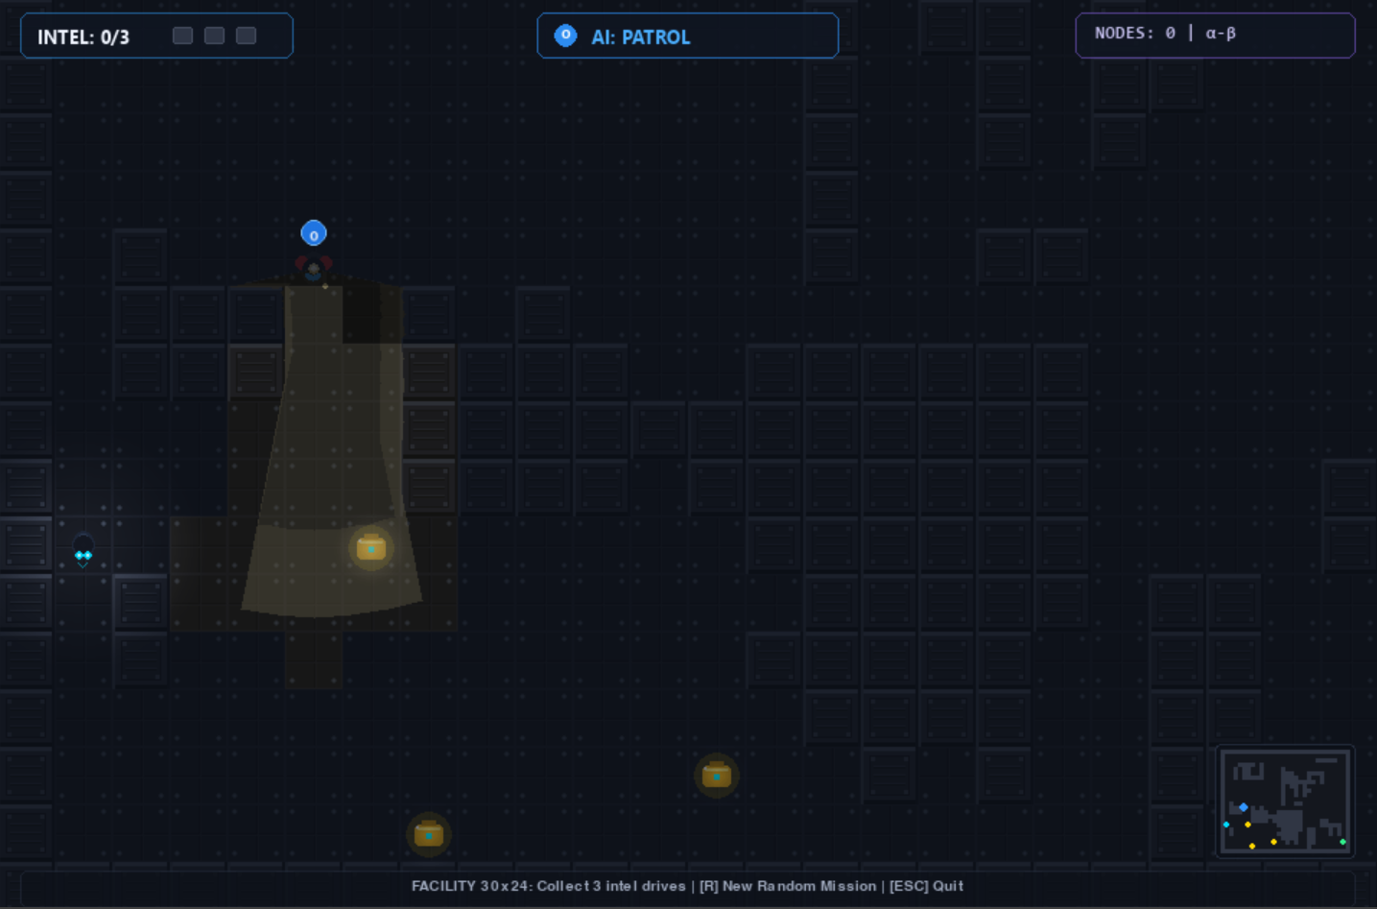
Figure 4.1 Prototype: Guard in patrol state (Intel 0/3)
In Figure 4.1 no evidence has been collected, and the guard is in the Patrol state. Its limited vision area is visible on the map.
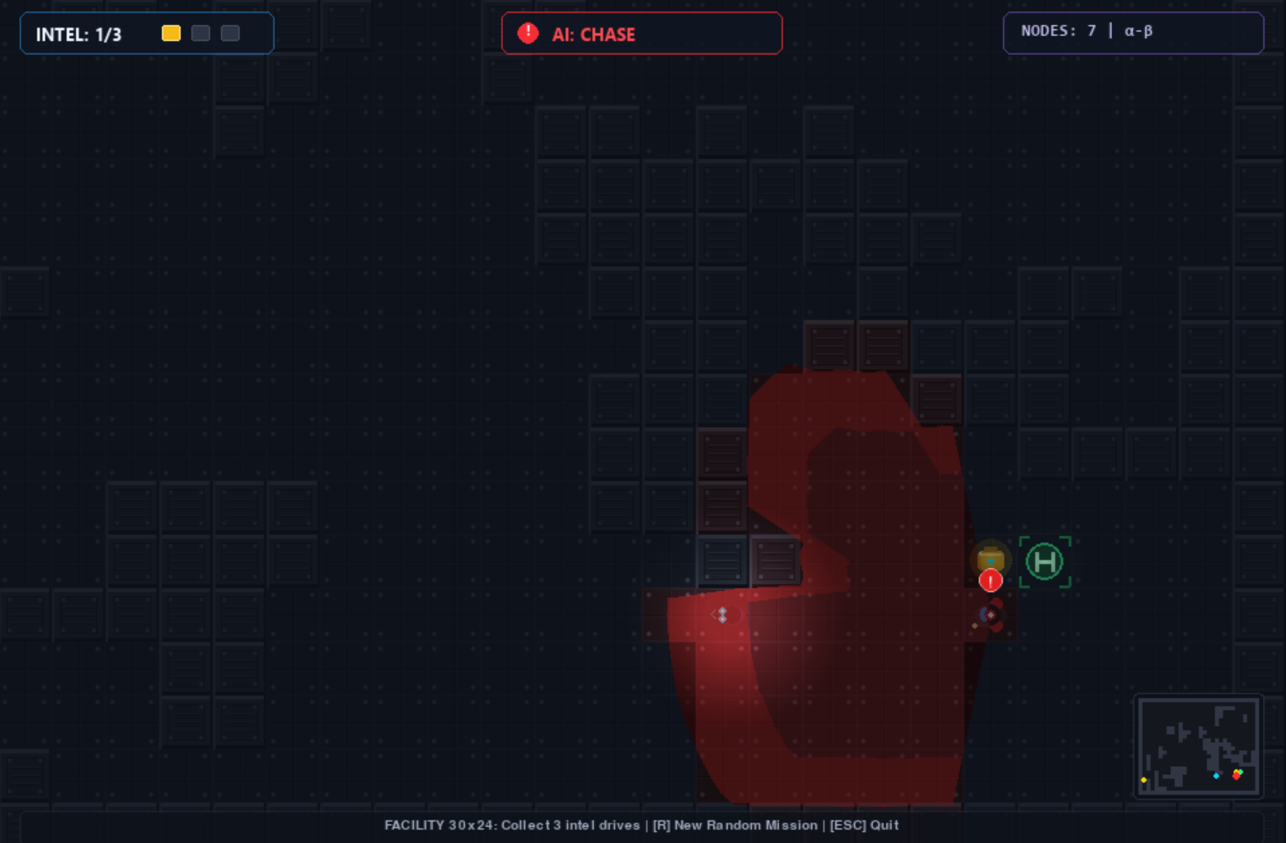
Figure 4.2 Prototype: Guard in chase state (Intel 1/3)
In Figure 4.2 one evidence item has been collected, and the guard has detected the player and entered the Chase state. The display shows that the Alpha-Beta search evaluated 7 nodes for the current decision.
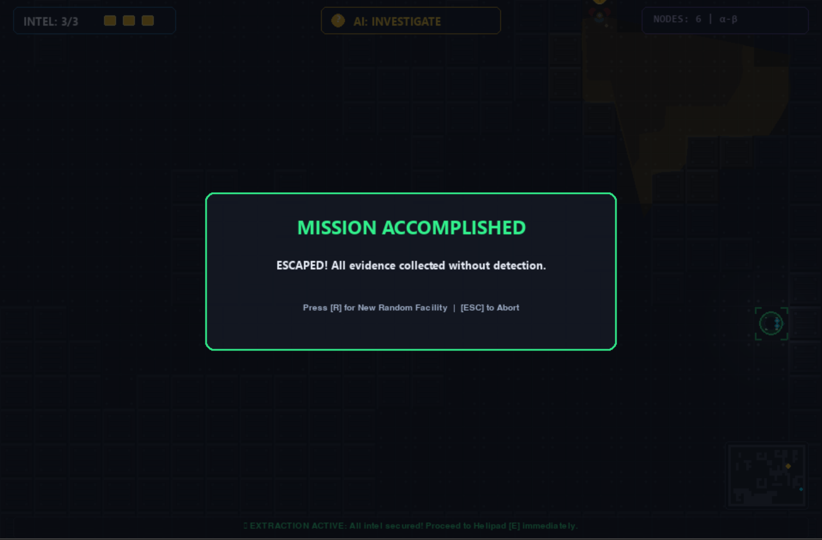
Figure 4.3 Prototype: Mission accomplished (Escape outcome)
Figure 4.3 shows the escape outcome, in which all three evidence items have been collected without detection and the player has escaped.
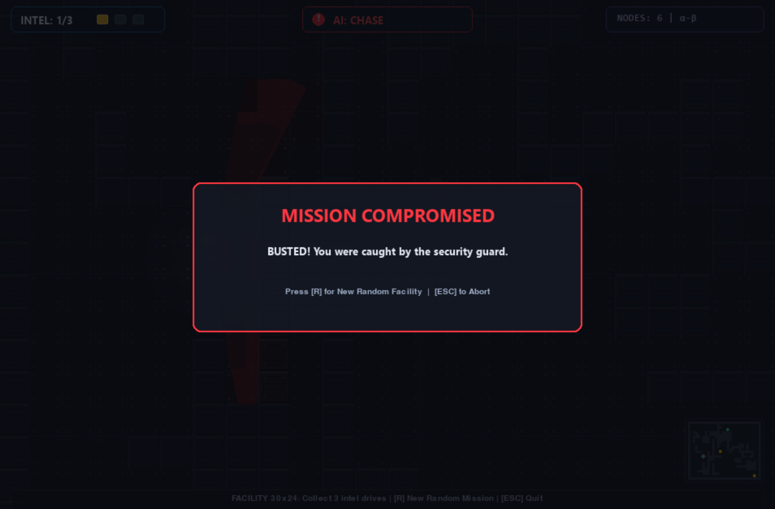
Figure 4.4 Prototype: Mission compromised (Caught outcome)
Figure 4.4 shows the caught outcome, in which the player is caught by the security guard before completing the objective.
Evaluation plan. No measured gameplay results are available yet, so no performance figures are reported in this phase. The guard will be evaluated using the repeatable test cases in Table 4.1.
Table 4.1 Planned test cases
S. No. | Test case | Expected behaviour
1 | The player moves quietly outside the guard's field of view. | The guard stays in Patrol.
2 | A noise event occurs. | The guard enters Investigate.
3 | The player enters the guard's line of sight. | The guard enters Chase.
4 | The guard loses visual contact with the player. | The guard returns to Patrol via Return.
5 | The player collects all three evidence items and reaches the exit. | The escape outcome is reached.
6 | The player is caught before completing the objective. | The caught outcome is reached.

The following metrics will be recorded: correct FSM transitions, validity of calculated routes (including path length and nodes explored), detection response, escape and caught outcomes, and decision-making runtime. The AI-controlled guard will be compared with a baseline guard that follows a fixed route and does not use sensing or A* pathfinding. The behaviour of the search with and without Alpha-Beta pruning will also be compared.
Challenges and solutions. The main challenges identified and the approaches taken are as follows:
- Guard behaviour: managed through FSM-based state management, with decision logic separated from movement logic.
- Navigation: handled with A* pathfinding, with path validation and recalculation when a target becomes unreachable.
- Detection: line of sight and noise are combined, so the guard does not receive perfect information.
- Algorithm integration: addressed through modular development and testing, using a shallow search depth to keep the AI responsive.

CHAPTER 5
CONCLUSION
This report has presented ShadowTrace, an AI-based intrusion detection game in which a player collects three evidence items and escapes from a grid-based facility while avoiding a security guard. The problem, objectives and scope were defined, the existing literature on pathfinding, state machines and adversarial search was reviewed, and a research gap was identified in combining noise-based investigation, visual detection, state-based behaviour and obstacle-aware navigation in one compact scenario.
The proposed system answers this gap with a modular design: an FSM with Patrol, Investigate, Chase and Return states, a perception layer using line of sight and noise, A* pathfinding, and a Minimax decision component with Alpha-Beta pruning. The design is documented through the system architecture, the data flow diagram, the guard state-transition diagram and the development workflow, together with the security requirements, threat model and controls. The current prototype demonstrates the guard's states, the evidence objective and the caught and escape outcomes.
The work planned until the final review is to complete the core game implementation, integrate and test the AI algorithms, refine the guard behaviour, conduct gameplay testing, and document the results and prepare the final presentation. The measured results from this test, including the comparison with the fixed-route baseline guard, will complete the evaluation of the project.

FUTURE SCOPE

The ShadowTrace: AI Based Intrusion Detection Game can be further enhanced to improve the intelligence of the security guard, increase gameplay complexity, and provide a more realistic stealth gaming experience. In future development, adaptive difficulty mechanisms can be introduced to adjust the guard's detection range, movement speed, and investigation behaviour according to the player's performance. The game can also be extended to include multiple AI-controlled guards that coordinate their patrol routes and share information about suspicious activities. Advanced pathfinding algorithms can be implemented and compared with A* to evaluate navigation efficiency in larger and more complex environments. The existing perception system can be enhanced by incorporating variable noise levels, different fields of vision, and environmental conditions to make detection more realistic. Furthermore, machine learning techniques can be explored to enable the guard to learn from player movement patterns and adapt its behaviour over repeated gameplay sessions. Dynamic environments containing randomly generated maps, movable obstacles, locked doors, and security cameras can also be introduced to increase replayability and challenge. The Minimax algorithm with Alpha-Beta pruning can be improved through better evaluation functions and search strategies to enhance decision-making efficiency. Future versions may also incorporate a gameplay analytics system to record player movements, guard decisions, detection response time, path efficiency, and game outcomes for systematic performance evaluation. Additional features such as multiple levels, improved graphical interfaces, multiplayer gameplay, and configurable difficulty settings can further enhance the overall gaming experience. These improvements would help transform ShadowTrace into a more scalable and intelligent stealth game while continuing to demonstrate the practical application of Artificial Intelligence techniques in game development.

REFERENCES
[1] P. E. Hart, N. J. Nilsson, and B. Raphael (1968). A formal basis for the heuristic determination of minimum cost paths. IEEE Transactions on Systems Science and Cybernetics, 4(2), 100-107. https://doi.org/10.1109/TSSC.1968.300136
[2] I. Millington and J. Funge (2016). Artificial Intelligence for Games (3rd ed.). CRC Press, Boca Raton, Florida. This book discusses game AI techniques, including pathfinding, decision-making, and autonomous character behaviour.
[3] J. Orkin (2006). Three states and a plan: The AI of F.E.A.R. Proceedings of the Game Developers Conference 2006, San Jose, California. Available at: https://gdcvault.com/play/1013394/Three-States-and-a-Plan
[4] S. Russell and P. Norvig (2021). Artificial Intelligence: A Modern Approach (4th ed.). Pearson, Hoboken, New Jersey. ISBN: 978-0-13-461099-3.
[5] S. Rabin, Ed. (2002). AI Game Programming Wisdom. Charles River Media, Hingham, Massachusetts.
[6] C. W. Reynolds (1999). Steering behaviors for autonomous characters. Proceedings of the Game Developers Conference 1999, San Jose, California, pp. 763-782. Available at: https://www.red3d.com/cwr/papers/1999/gdc99steer.html
[7] S. J. Russell and P. Norvig (1995). Artificial Intelligence: A Modern Approach. Prentice Hall, Englewood Cliffs, New Jersey. This earlier edition provides foundational material on search algorithms, intelligent agents, and problem-solving techniques.
[8] R. E. Korf (1985). Depth-first iterative-deepening: An optimal admissible tree search. Artificial Intelligence, 27(1), 97-109. https://doi.org/10.1016/0004-3702(85)90084-0
[9] D. E. Knuth and R. W. Moore (1975). An analysis of alpha-beta pruning. Artificial Intelligence, 6(4), 293-326. https://doi.org/10.1016/0004-3702(75)90019-3
[10] J. Pearl (1984). Heuristics: Intelligent Search Strategies for Computer Problem Solving. Addison-Wesley Publishing Company, Reading, Massachusetts.
[11] R. S. Sutton and A. G. Barto (2018). Reinforcement Learning: An Introduction (2nd ed.). MIT Press, Cambridge, Massachusetts. Available at: http://incompleteideas.net/book/the-book-2nd.html
[12] S. LaValle (2006). Planning Algorithms. Cambridge University Press, Cambridge, United Kingdom. Available at: https://lavalle.pl/planning/
[13] M. Buckland (2004). Programming Game AI by Example. Wordware Publishing, Plano, Texas. This book presents practical approaches to game AI, including finite-state machines, steering behaviours, and autonomous agents.
[14] R. Nystrom (2014). Game Programming Patterns. Genever Benning. Available at: https://gameprogrammingpatterns.com/state.html
[15] Python Software Foundation (2026). Python 3 Documentation. Python Software Foundation. Available at: https://docs.python.org/3/
[16] Pygame Community (n.d.). Pygame Documentation. Pygame documentation and API reference for developing interactive games with Python. Available at: https://www.pygame.org/docs/
[17] J. Funge, X. Tu, and D. Terzopoulos (1999). Cognitive modeling: Knowledge, reasoning and planning for intelligent characters. Proceedings of the 26th Annual Conference on Computer Graphics and Interactive Techniques (SIGGRAPH '99), pp. 29-38. Association for Computing Machinery. https://doi.org/10.1145/311535.311537
[18] M. Ghallab, D. Nau, and P. Traverso (2004). Automated Planning: Theory and Practice. Morgan Kaufmann Publishers, San Francisco, California.

APPENDIX

A. WEEKLY DEVELOPMENT LOG SUMMARY
The project was planned and recorded over a six-week development period. The weekly project journal is summarized in Table A.1.
Table A.1 Weekly development log summary

Week | Phase | Key activities | Main challenge / lesson
1 | Project setup, game concept and grid environment | Finalised the intruder-versus-guard concept; created the grid environment with walkable cells, walls, evidence locations and an exit; set up the Python / Pygame project structure. | Keeping the game simple while demonstrating multiple AI concepts. A grid representation supports both gameplay and pathfinding.
2 | Player movement, evidence collection and game environment | Implemented WASD movement; added three evidence items, an exit, walls and collision rules; set the guard start position and patrol area. | Managing movements near walls and collecting evidence only once. Each component is tested before AI is added.
3 | A* pathfinding and Finite State Machine | Implemented grid-based A* with movement cost and a Manhattan-distance heuristic; created the guard FSM and its transitions. | Unreachable targets and invalid paths. A* answers how to move, and the FSM controls which behaviour is active.
4 | Perception system: line of sight and noise detection | Added limited vision range and noise events at evidence locations; the guard investigates noise instead of knowing the player's location. | Choosing detection ranges without giving the guard perfect information. Limited information makes the NPC more realistic.
5 | Minimax and Alpha-Beta decision-making and AI integration | Defined guard choices such as Investigate Noise and Continue Patrol; implemented shallow Minimax with Alpha-Beta pruning; integrated it with the FSM and A*. | Keeping the decision tree small for real-time play. Minimax decides what to do, the FSM manages behaviour and A* decides how to get there.
6 | Testing, performance evaluation, polish and viva preparation | Tested player routes and detection situations; verified the Patrol, Investigate, Chase and Return transitions; checked A* paths; compared search with and without Alpha-Beta pruning. | Unexpected transitions and invalid paths in edge cases. Repeated test cases and measurable indicators are used to evaluate the AI.

B. OVERALL PROJECT REFLECTION
Key skills and concepts learned: A* pathfinding, the Manhattan heuristic, Finite State Machines, line-of-sight detection, noise-based perception, Minimax, Alpha-Beta pruning, grid-based game design, Pygame and basic AI performance evaluation.

Biggest technical challenge: integrating decision-making with real-time NPC behaviour while keeping the AI responsive and preventing unnecessary search.

Things that can be done differently: use more modular architecture from the beginning and define measurable evaluation metrics before implementation.

Outcome against the original plan: the project combines a simple stealth game with A*, an FSM, perception and Minimax with Alpha-Beta pruning. The scope was kept manageable for the first game-development project while retaining meaningful AI content.

